**PRACTICAL 7**

**ENTRY FEES FOR VISITORS AT PARK**

**Code:**

**Output:**

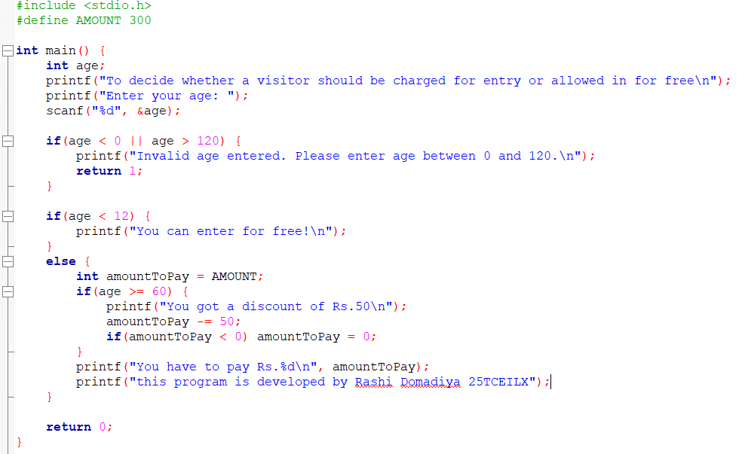

1. **for senior citizen:**

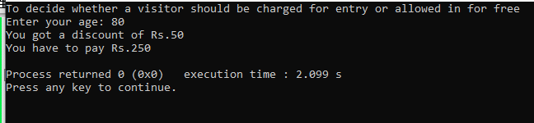

1. **for a kid:**

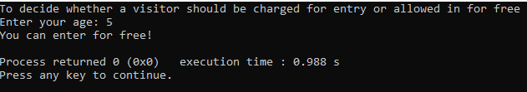

**3)for invalid age:**

